# CS 255 System Design Document Template

This template lays out all the different sections that you need to complete for Project Two. Each section has guidance to prompt your thinking. You will need to continually reference the interview transcript as you work to make sure that you are addressing your client’s needs. There is no required length for the final document. Instead the goal is to complete each section based on what your client’s needs are. Remove this note when you are finished, and replace all bracketed text with the relevant information.

## UML Diagrams

### UML Use Case Diagram

*[ 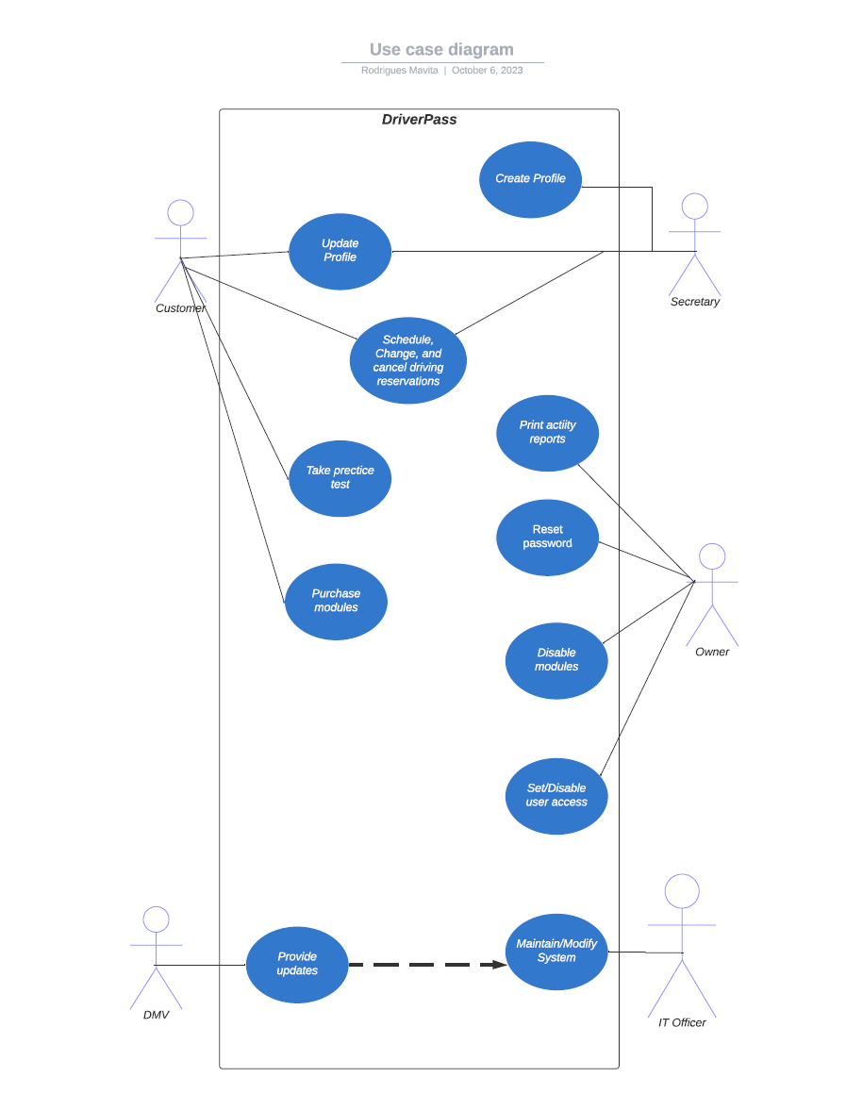 ]*

### UML Activity Diagrams

*[* 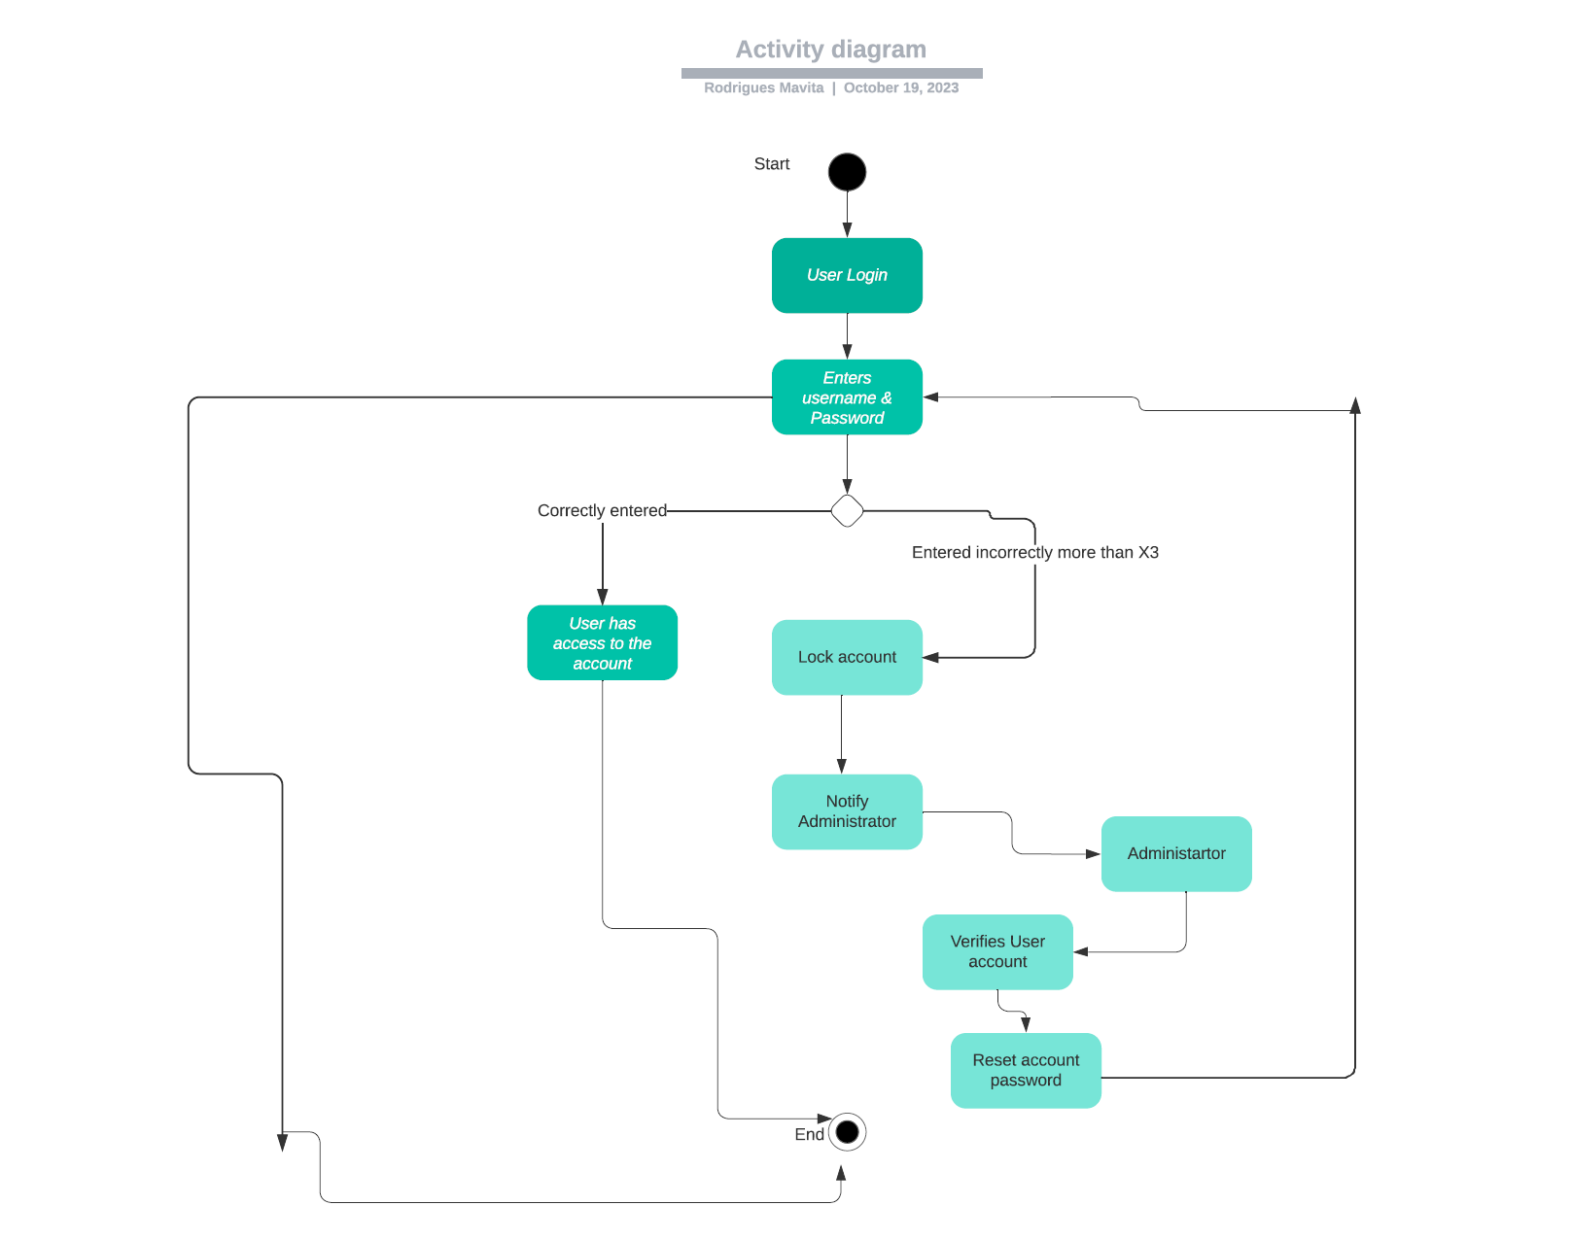

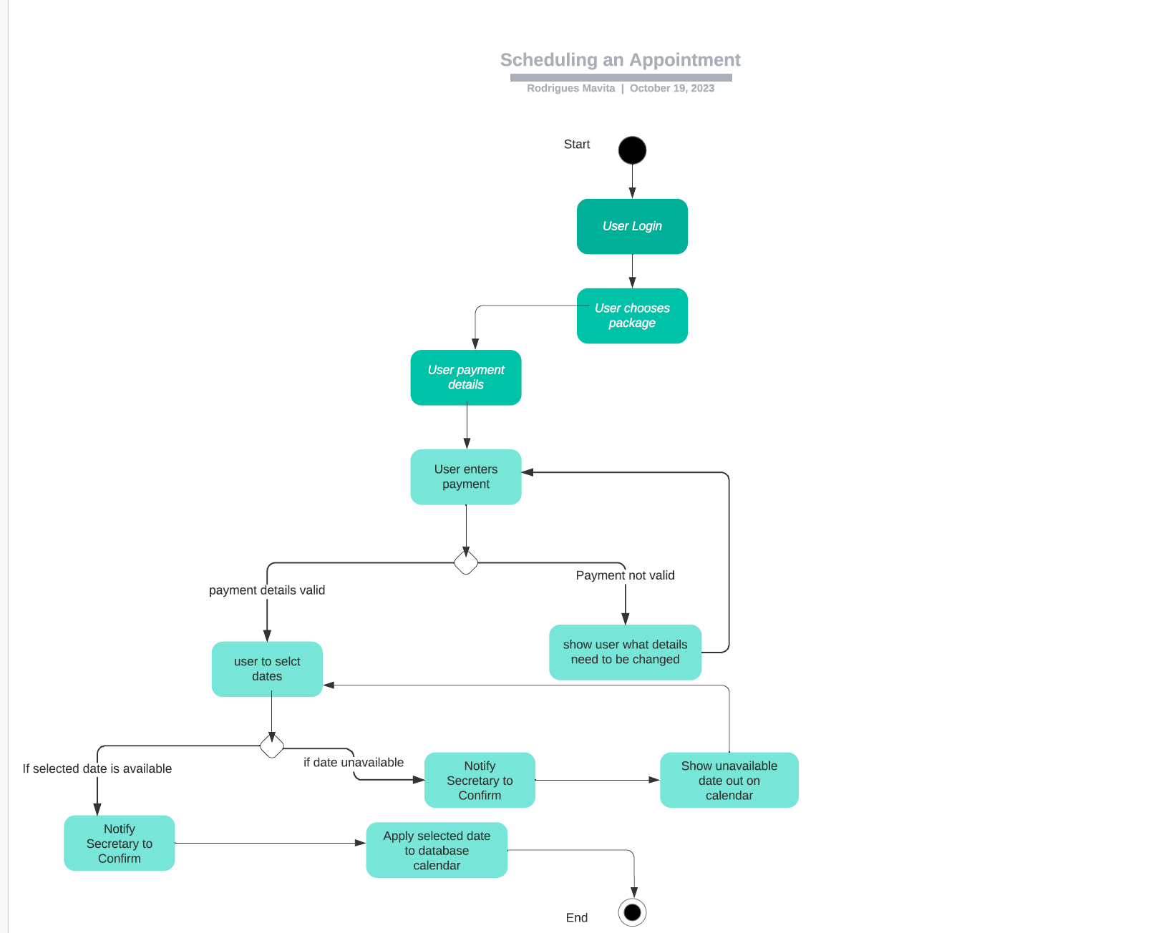*.]*

### UML Sequence Diagram

*[ 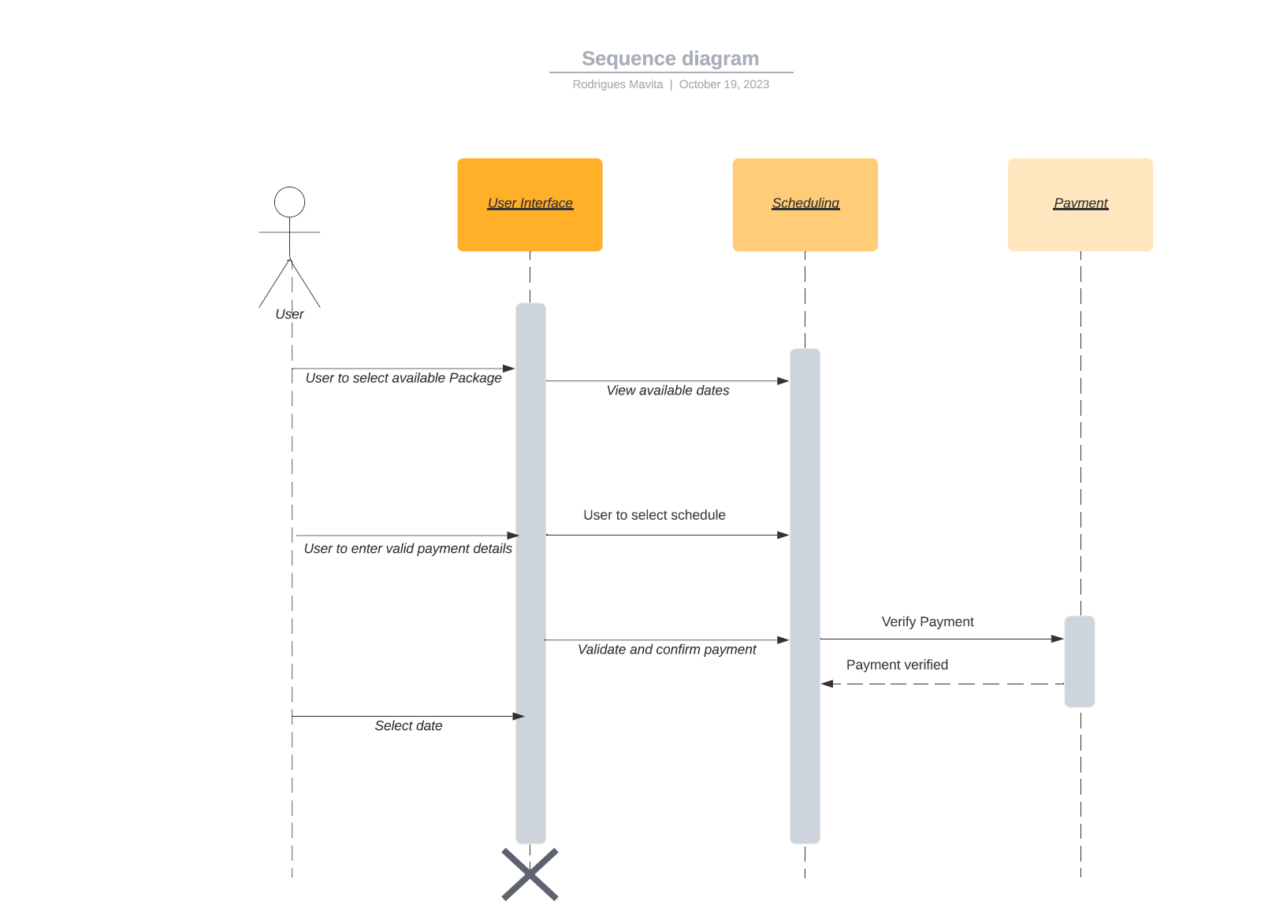 .]*

### UML Class Diagram

*[ 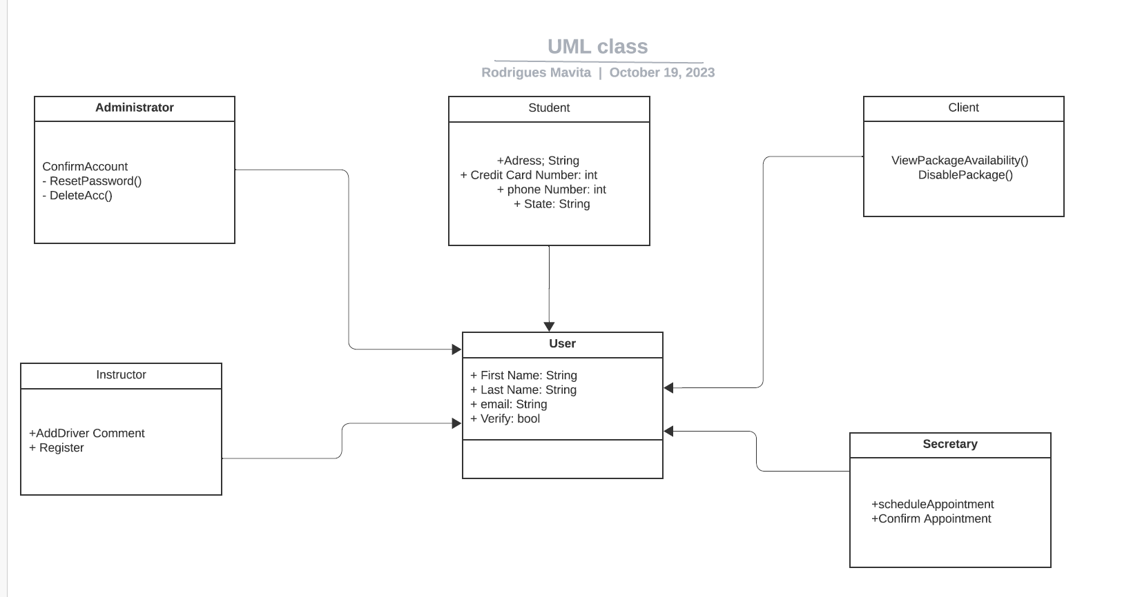.]*

## Technical Requirements

*[* **Hardware Requirements:**

* Web Servers
* Database Server
* Network Infrastructure
* Mobile DevicesWorkstations
* Driving Simulation Equipment

**Software Requirements:**

* Operating Systems
* Web Development Tools
* Backend Development
* Database Management System (DBMS)
* Cloud Services
* Security Software
* Version Control
* User Authentication and Authorization
* Payment Gateway
* Notification Services

**Tools and Development Environment:**

* Integrated Development Environment (IDE)
* Database Design Tools
* Testing Frameworks
* Monitoring and Analytics Tools

**Infrastructure and Hosting:**

* Cloud Hosting
* SSL Certificates
* Backup and Disaster Recovery
* Compliance and Security Measures
* Continuous Integration/Continuous Deployment (CI/CD)

**Documentation and Support:**

* User Documentation
* Maintenance and Support
* Training Tools

These technical requirements are vital to ensuring that the DriverPass project is implemented successfully, operates securely, and provides an optimal experience for both users and administrators. The selection of specific technologies, tools, and infrastructure components will depend on the project's scope, budget, and scalability requirements.

*.]*